

Spotify Review Analysis using LDA and LSA and Fuzzy based Smart Home Controller

Lecturer: Dr. Alireza Daneshkhah
Student Name & Id: ANU THOMAS (12386712)
JUSEL JUSTIN (12646627)
MSc. Data science and computational Intelligence (MAY 2022)

Abstract
Spotify was among the most popular online music streaming service providers as of March 2022, with millions of monthly users that included paying subscribers. This made Spotify one of the most successful companies in the industry. It features music and podcasts that are spoken in a number of languages and provides something fascinating for everybody who is actively listening to listen to. People will convey their ideas, opinions, and feedbacks about a product or service via the use of active reviews and comments. Some of them aren't hesitant to comment about their experience with this programme by rating it on the Google Play Store Review. Others of them are. Although evaluations are helpful to app developers, artists, and content producers, it might be difficult to classify the assessments and comprehend the requirements of the clients. However, by using topic modelling, we can easily examine the feedback provided by users and enhance their overall experience. The ratings, as well as the comments, from the Spotify app, have been taken into consideration for this project. Latent Dirichlet Allocation (LDA) and Latent Semantic Analysis are the two methods that have been used in the process of carrying out this research. Both of these methods are considered to be latent techniques (LSA). Following the completion of the study, the approach that will prove to be the most successful in light of the current situation will be determined. FLC is the most researched application of fuzzy set theory, fuzzy reasoning, and fuzzy logic. FLC can regulate industrial operations, biomedical devices, and even security. FLC is most successful when used to handle tough, ill-defined challenges by a human operator without previous knowledge of the problem's dynamics. Fuzzy Logic toolbox in MATLAB is essential for creating smart home applications. All disciplines may use it. Using MATLAB's FIS toolbox, we'll create a smart home-appliances system to operate a fire extinguisher, air purifier, water pump, fan, and light. Fire, pollution, soil humidity, and motion sensors are needed to manage these appliances.
Keywords—MATLAB, Python, LDA,LSA, FIS, Spotify, Review analysis
Table of content
Task-1……………………………………………………………………………………………………...4
1. INTRODUCTION OF SPOTIFY REVIEW ANALYSIS……………………………………………...4
2. TOPIC MODELLING………………………………………………….………………………………4
3. PROBLEM DOMAIN………………………………………………………………………………….5
A. Spotify Application…………………………………………………………………………….5
B. Reviews Analysis………………………………………………………………………………5
C. Importance of Review Analysis………………………………………………………………..6
4. METHODOLOGIES…………………………………………………………………………………...6
A. About Dataset………………………………………………………………………………......6
B. Latent Dirichlet Allocation (LDA)……………………………………………………………..7
C. Latent Semantic Analysis (LSA)……………………………………………………………….8
5. IMPLEMENTATION & RESULTS…………………………………………………………………...9
A. Latent Dirichlet Allocation (LDA)……………………………………………………………..9
B. Latent Semantic Analysis (LSA)……………………………………………………………...13
6. CONCLUSION………………………………………………………………………………………..17
Task – 2………………………………………………………………………………………………...17
1. PART 1 FUZZY LOGIC CONTROL BASED SMART HOME APPLICATION…………………..17
A. Fuzzy logic control system……………………………………………………………………18
B. FLC Design Assumptions…………………………………………………………………….18
C. Architecture of Fuzzy Logic Control…………………………………………………………18
D. Principal Constituents of the FLC…………………………………………………………….19
E. Steps in Designing FLC……………………………………………………………………….19
F. Advantages…………………………………………………………………………………….19
G. Disadvantages………………………………………………………………………………...20
H. Implementation of FIS Smart home system…………………………………………………..20
2. PART 2 FIS BASED SMART HOME APPLICATION USING CUSTOMISED MEMBER FUNCTION.................………………………………………………………………………………..…24
3. PART 3 OPTIMISING CEC 2005 FUNCTIONS…………………………………………………….27
4. CONCLUSION………………………………………………………………………………………..29
REFERENCES…………………………………………………………………………………………...29
APPENDIX………………………………………………………………………………………………30

Task-1

Introduction of Spotify review Analysis
LDA and LSA are two of the most prominent methodologies that are used when it comes to topic modelling for text data in the modern world, which is described by the development of an abundance of data, in particular text data. These two methodologies are LDA and LSA. The generation of themes is accomplished by these two separate algorithms via the use of semantic distances. It is possible to think of semantic distances as a measurement of how closely connected the phrases in a corpus are to one another. The skills of these two algorithms could sometimes be roughly comparable to one another, but this will be contingent on the specifics of the activity that has to be finished.
LDA generates subject threads based on the previous Dirichlet Distribution, whereas LSA creates a word-document correlation matrix. LDA uses the previous Dirichlet Distribution as a reference to build topic threads. This emphasises thematic threads. The LDA method places an emphasis on the generation of thematic threads by making use of the preceding Dirichlet Distribution as a point of reference. Because of the similarities and differences between these two algorithms, it is extremely important to have a solid understanding of the conditions under which each of these algorithms should be employed and when they should be put into action.
This is because of the fact that it is extremely important to have a solid understanding of the conditions under which each of these algorithms should be employed. It is incredibly important to have this knowledge because it is extremely important to have a grasp of the similarities and differences that exist between these two algorithms. LDA and LSA are going to be employed during the course of this research in order to analyse the behaviour of the Spotify application. This evaluation will be done in order to draw conclusions about how the programme functions. Because this analysis may be of such great significance, it is essential to depend on an algorithm that is able to carry out its tasks in the proper way in order to provide a picture that is more reflective of the performers and songs that are included within the corpus.

Topic Modelling
In order to provide us with a concept of the work that would serve as the basis for evaluating the performance of these two algorithms, I need to first have an understanding of subject modelling. The primary objective of this subfield of Natural Language Processing and Machine Learning, which is widely regarded as one of the most fascinating areas of research in these two areas, is the identification of subjects and the connections between them in a variety of texts. This application will provide us an overview of the topics that are discussed in a certain document or a group of papers. If we have a document that often refers to the names of cities and that document makes frequent reference to the same places throughout its whole, it is not hard for a person who is reading it to deduce that the document may be about travelling or touring. When we have a huge number of papers, it may be difficult to determine what precisely each one is about. As little as this may seem, it is helpful to have a computer do that for us so that we don't have to worry about it. And here's where topic modelling comes into play: when it comes to a computer being able to accomplish that.

Problem Domain

Spotify Application
Spotify has swiftly overtaken other streaming media services as the most widely used one worldwide. We realise that the firm has access to an unfathomably vast amount of data regarding the manner in which individuals listen to music when we consider the tremendous number of customers who use the service's free listening tier. We realise that the corporation has access to a huge amount of data when we consider the vast number of consumers that utilise the free listening tier. This is as a result of the company keeping track of how often each customer listens to music.
When reduced to its simplest form, Spotify uses this information to power a recommendation engine that, as far as the streaming sector is concerned, lacks even one comparable rival. We may opt to look elsewhere for a music-streaming service until these problems are rectified since it is terrible that the company hasn't been able to keep up with the competition in other important areas.
The great majority of artists and record companies come to Spotify first when they are thinking about licencing their music because of the enormous number of people who listen to the content it offers. It is very effective in introducing listeners to new artists in the pop and rap music genres, respectively, thanks to the playlists it keeps. The sole source that accomplishes this is Spotify, which is the only streaming service that tries to provide a list of an artist's future tour dates. Spotify offers the greatest selection of social sharing alternatives and enables us to see in real-time what other users are playing at any given time. We will learn that this service is beneficial to us if we show an interest in the music that our friends are listening to and if we get curious about what they are playing.
In addition, a significant segment of the creative community is harbouring a great deal of hostility. Others have concerns about the streaming service's quality, and there are concerns about the significant investments the business has made in industries unrelated to music. Others worry about the company's substantial investments in industries unrelated to music. Some individuals disagree with the idea that the free tier lowers the overall amount of money distributed in royalties, and they voice their disagreement by making this claim..

Reviews Analysis
The process of translating unstructured review data into structured review data that may be utilised to aid decision-making is referred to as review analysis. The following are some of the most common applications:
- Product feature ideas are derived through reading customer feedback to determine which aspects of the product are most valued.
- Roadmap prioritisation is the process of deciding which features the development team should concentrate on first.
- Tracking bugs involves continuously monitoring fresh user feedback in real time.
- Customer care ratings are used to identify which departments in charge of providing service to customers are doing a good job.
Product reviews are one of the most informative and helpful sources of behind-the-scenes information that can be found online. These often include golden nuggets that may be used to direct development, debug new projects, and enhance the experience that customers enjoy. They give a useful benchmark that can be used to compare their products and services to those of their competitors, highlighting both the areas in which they excel and those in which they need to improve .
However, despite the fact that they might be beneficial, consumer reviews suffer from a significant issue. In qualitative terms, attempting to characterise the human experience is always going to be a messy endeavour, and this is not an exception. Attempting to make sense of customer experiences that have been expressed in thousands of unstructured evaluations might, at times, seem like trying to clean up the shells that are scattered down a beach.

Importance of Review Analysis
Review analysis is crucial because it enables, we to understand the perceptions that consumers have of their product, whether it be an application, a website, or an experience. At its core, it is an activity that is focused on the consumer. It gives we the ability to make judgments about what aspects of their business should be improved based on the priorities of their consumers.

Methodologies

About Dataset
The data for this Spotify reviews dataset came from the Kaggle dataset, which is regarded as a secondary data source. This dataset was utilized to gather the data. As of the month of March 2022, it had over 422 million monthly active users, of whom 182 million were paying members, making it one of the most major suppliers of music streaming services. This elevated it to the status of being one of the most successful businesses in the sector. Some of them do not hesitate to share their experience while using this application along with the rating that they have offered to indicate how happy they are on Google Play Store Review. Others do not share their experience while using this program. Some users have reported that others have not shared their experiences while using this software. The following is a list of the properties of the dataset, which includes reviews:
- Time submitted is a date and time object
- Review is a string
- Rating is an integer
- Total_thumbsup is an integer
- Reply is string

Latent Dirichlet Allocation (LDA)
The vast academic field known as "data mining" has led to the development of a body of knowledge that provides methods for the management of large document archives. Methodologies might also be seen to be examples of these tactics. The passing of time has resulted in a heightened proficiency in this capacity (text corpus). There are presently tools that can summarize a corpus, organize articles into categories, identify recurrent themes, and help users find articles that are relevant to their requirements. These tools are currently accessible. These materials are currently accessible for your use currently. A subset of methods known as topic modelling is especially desirable because it may provide a database of patents or other publications that can be quickly investigated and used in DbA. This makes subject modelling one of the most appealing classes of approaches. Because of this, enrolling in the topic modelling technique class is something that is highly recommended. Because of this, DbA is acquiring more and more followers all the time, which is one of the reasons why.
The LSA served as the basis upon which topic modelling subsequently developed into its several distinct iterations, and this foundation was exploited. Inputs to methods might sometimes take the shape of a word-document matrix, which counts the number of times a certain phrase appears inside a single document and maintains track of the number of times a particular term appears within that document. Conventional techniques of clustering, such as k-means clustering, and dimensional reduction approaches, such as Principal Component Analysis (PCA), were used by the researchers who conducted the study in its original form. Even though they were used, these strategies only had a moderate amount of success at best. The findings that were provided by the clustering procedures and the dimensionality reduction methods were, in many cases, quite convoluted and difficult to understand because they were drawn from very complex data. This is because the procedures and methods used to reduce the dimensionality of the data. The steps involved in the clustering process were quite rigid in their nature. LDA was a revolutionary approach that was developed in the early years of the new century. It is now known as the Latent Dirichlet Allocation. The name of the organization known today as the LDA has been used to refer to itself in a myriad of different guises at several stages in its history. Notable is the fact that supervised LDA techniques give the user the ability to select themes to concentrate on, after which the corpus analysis makes to incorporate these seeded topics into its overall probabilistic model. This is a significant advantage over unsupervised LDA techniques. This is a substantial benefit when compared to techniques using unsupervised LDA. When compared to methods that use unsupervised LDA, this represents a significant advantage on its own.
The application of nonparametric Bayesian techniques to the problem of recognizing hierarchies of humans [11, 12] is another key advance that agrees with the results of LDA and is a considerable step forward. In recent years, a few researchers in the academic world have investigated several variants of principal component analysis (PCA), as well as different formulations of least-squares regression, with the intention of developing topic modelling. Within the scope of this category are items like sparse matrix formulations as well as several other kinds of formulations. Compared to LDA and LASSO regression [14] and sparse PCA [15] while conducting their research. This comparison took place during their study. They found that all three approaches were successful in topic modelling; however, LASSO and sparse LDA were much more effective in terms of the efficiency of both time and effort than the other two approaches. Another group investigated the feasibility of employing non-negative matrix factorization (NMF) [16] for interactive topic modelling, and they found that the computational performance was sufficient [17].

Latent Semantic Analysis (LSA)
By subjecting the text to the methodology and using a technique known as LSA, which is a tool for computational text analysis, it is possible to generate a semantic space from a body of text. This is done by taking the text and applying it to the methodology.
It is feasible to draw certain inferences from the results of the LSA and the findings of the LDA by comparing them in a roundabout way. One may make use of a method known as LSA, which is a tool for the computational analysis of text, to accomplish the goal of extracting a semantic space from a body of text in order to fulfil a certain objective. It is conceivable that this constructing procedure will really take place. After that, a wide variety of applications [18] use this semantic space to evaluate the degree of similarity between individual words, phrases, paragraphs, and even whole publications. This evaluation may be done in a variety of ways. One way to do this is to examine the meaning of the text individually, looking at the words, phrases, and paragraphs. When comparing individual words, phrases, paragraphs, or even whole works of literature, one of the things that is taken into consideration all along the comparison process is the semantic space that exists between each of these components.
In any case, the findings of the LSA may be used to identify how closely related the two collections of data are to one another. As a direct result of the research described in reference [22], structures were developed and implemented. This method leads to the construction of structures that, when applied to patent spaces, result in those spaces being meaningfully ordered into clusters of labelled regions and clusters of labelled regions. The construction of these structures is made possible by using this approach, which yields the construction of those structures. The meaningful ordering of the patents that are contained inside those categories is formed by the degree to which they either have a functional similarity or a surface content similarity. Both factors are taken into consideration.
Examples show that information on cross-domain connections and the interchange of data based on functional similarity may be derived not only from function-based structures but also from surface content-based structures. This is possible because of the similarities between the two types of structures. The fact that function-based structures are the most prevalent home for such information does not change the fact that this is the case. This is always the case regardless of the structure that is there, thus it doesn't really matter. Given the parallels that exist between these two distinct kinds of systems, this is undoubtedly something that is capable of being done and is absolutely something that could be done.
In a larger sense, the LSA has been met with a mixed reception because of its inability to match observable data, such as anticipating human word associations. This failure has resulted in the LSA being unable to match observable data. This is because the LSA cannot match observable data, which is the cause of the problem. This is because the LSA cannot perform a data matching operation successfully. This is only one of the numerous reasons why things are the way they are. This is due of the fundamental importance of the spatial representation to LSA, which is the reason for this finding. Specifically, some of the factors contributing to this situation are as follows: In addition to imposing the triangle inequality, which is one of its many other qualities, this form enforces symmetry in the similarity of words. This is only one of its many features. These are very astute criticisms; nevertheless, they are predicated on comparing words to words, which, given the ever-increasing amounts of corpora and the sizes of repository spaces, may or may not become obsolete in the future.
Even though function-based structures are often thought of as more basic, this is the case. The fact that these two different kinds of structures are so comparable makes it possible for anything like this to take place. In a broader sense, the LSA has been greeted with various responses because it cannot match apparent facts, such as predicting human word connections. This is one of the reasons why the LSA has been received with such a response. This is one of the explanations, among other ones. This is because of the nature of the spatial representation that is important to LSA, which is why this is the case. Specifically, the reason why this is the case is as follows: This representation, among other things, ensures that the triangle inequality is adhered to and necessitates symmetrical relationships between words that are related. These objections are insightful, yet, they are founded on comparing words to words, which may or may not become irrelevant as the size of corpora and repository sizes continues to expand.

Implementation & Results

Latent Dirichlet Allocation (LDA)
In this section, we are performing a review analysis on Spotify Review. As of March 2022, Spotify has millions of monthly active users, including paying customers. It has music and podcasts in several languages for every engaged listener. People exchange ratings, thoughts, and feedback via active reviews and comments. Some review the app on Google Play Store. Though reviews are important to app developers, musicians, and content providers, it may be difficult to identify them and understand consumer needs. Using topic modeling, we can simply analyze concerns and improve user experience. This assignment uses Spotify reviews. Latent Dirichlet Allocation (LDA) and Latent Semantic Analysis are employed (LSA). The optimum approach will be decided after the examination.
The analysis on the Spotify reviews using Latent Dirichlet Allocation (LDA) is performed in the following Steps.

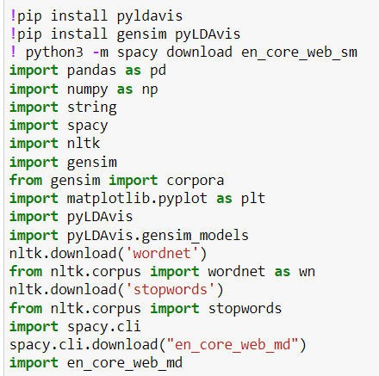
Figure.1 Importing Library packages

The library packages that need to be created for the LDA analysis are imported as shown in the above figure.
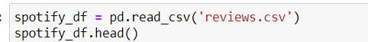
Figure.2 Reading a Dataset
The Pandas library is used to read a reviews.csv file into the data frame as shown in the above figure. And the sample dataset is shown in the below figure, which contains Time_submitted, Review, Rating, Total_thumbsup and reply as attributes.
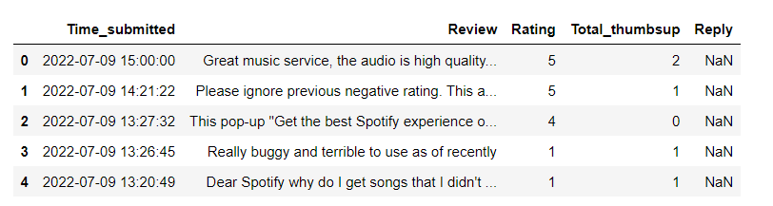
Figure.3 Sample Dataset
In this above sample, the reply attribute contains the entire column as Nan values. So, we need to drop this column.
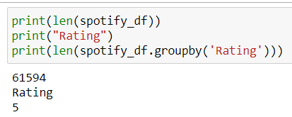
Figure.4 Dataset Analysis by Rating
In this rating analysis, we have obtained the length of data set as 61594, ratings are grouped into the categories as shown in the above figure.
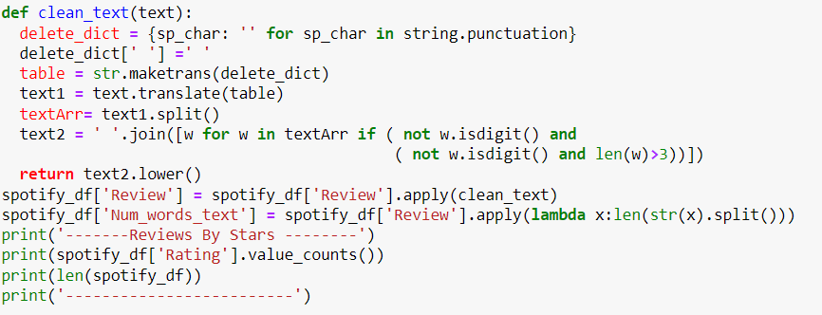
Figure.5 Dataset Cleaning and Reviews by stars.
As shown in the figure, we have created a function name that does clean text, which cleans the attribute called a review. To perform a clean operation on the data set, we have applied that function to that column using ‘. apply’ function, and then the cleaned data is stored in the same column of the same data set. We have printed the rating counts based on the stars given by the user, such as 1 to 5 stars. The count of each star is given in the below figure.

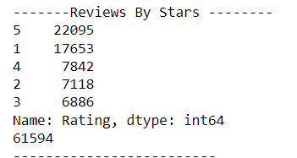
Figure.6 Rating Counts by Stars

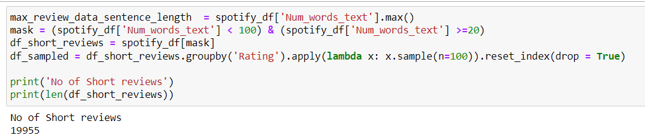
Figure.7 No of Short Reviews
In this step we have obtained the number of words in each review, and we have analyzed to the number of short reviews and obtained the counts of it as shown in the above figure.
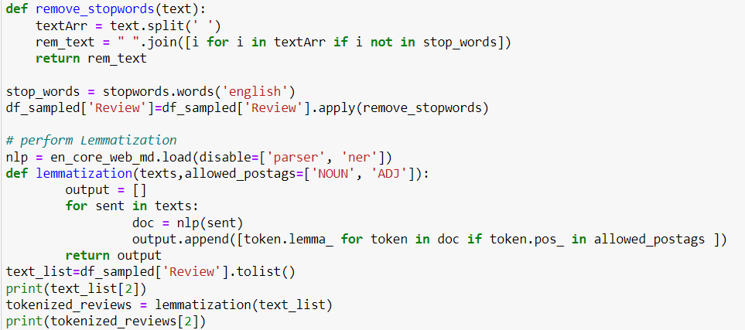
Figure.8 Remove words and Lemmatization
In this step we have created a function named as remove stop words which is used to find the stop word and we can remove those words. for that we first enable the English as an input for the stop word function. then we have applied that remove stop words function to the review column in the data frame. We have created another function named as Lemmatization, then we are performing Lemmatization on this review column. The below figure source that the tokenized review for the given input review using Lemmatization function.
Figure.9 Tokenised words for given text

From this above figure we are getting tokenize two words in a list format for the given input review asset text input

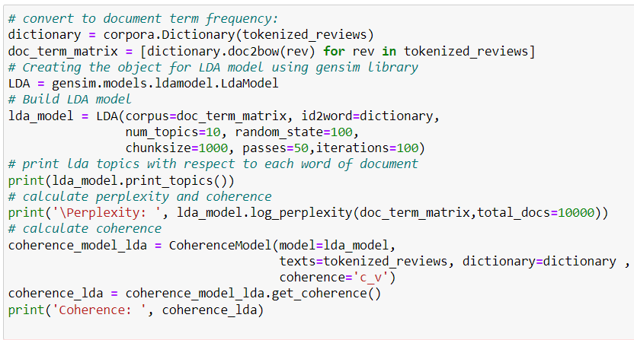
Figure.10 LDA Model implementation
In this step we have convert to document into term frequency and then we have created a matrix for the tokenized reviews. then we have enabled LDA model using genism module. the created Matrix and dictionary words using tokenizer reviews are given to the LDA model. then we have obtained the topics in the reviews with its latest values then we have calculated the perplexity and coherence of the texts.

Latent Semantic Analysis (LSA)
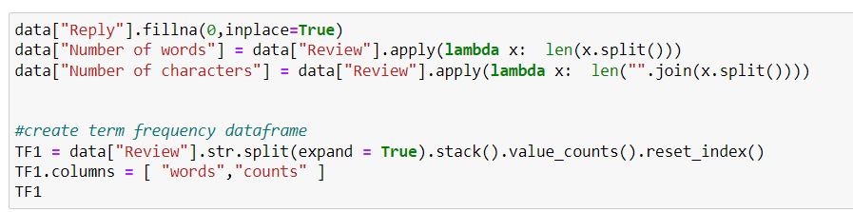
Figure.11 Frequency data frame of words and counts
In this step we have removed the reply to column by performing the fill null operation used in Pandas. then we have created a separate two columns name as ‘number of words’ and ‘number of characters using apply and Lambda function. then we have created a separate data frame for the frequency of words and counts of review column.

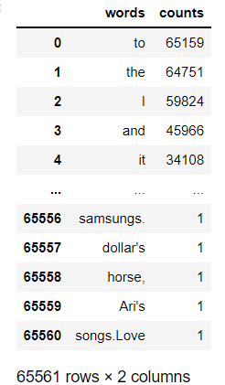
Figure.12 Frequency data frame

The above figure shows that the frequency data frame. The below figures shows that the bar plot for the frequency of the words.
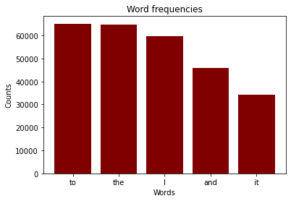
Figure.13 Frequency of words
The word cloud image for the given reviews text is shown in the below figure.
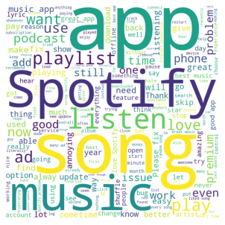
Figure.14 Word Cloud Image

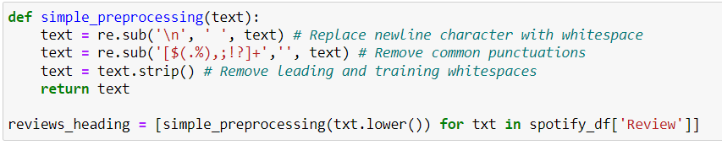
Figure.15 Pre-processing the data frame
The above figure shows that the function of pre-processing. In which it removes the common punctuations in the texts.

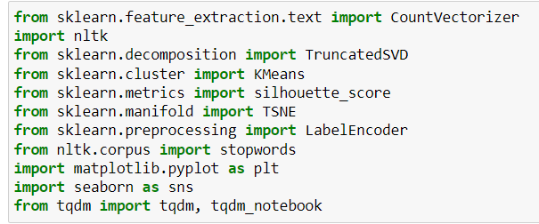
Figure.16 Importing library packages

The library packages are required for LSA is imported as shown in the above figure.
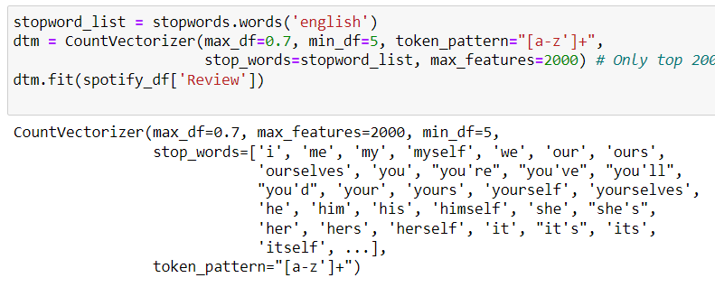
Figure.17 Count vectors

In this step we are enabling the English language for the stop words list and then we have created Count vectorizer using stop word, only for top 2000 most frequently occurring in the list. we have fitted the review column to that count vectorizer. the design of counter vectorizer shown in the above figure.
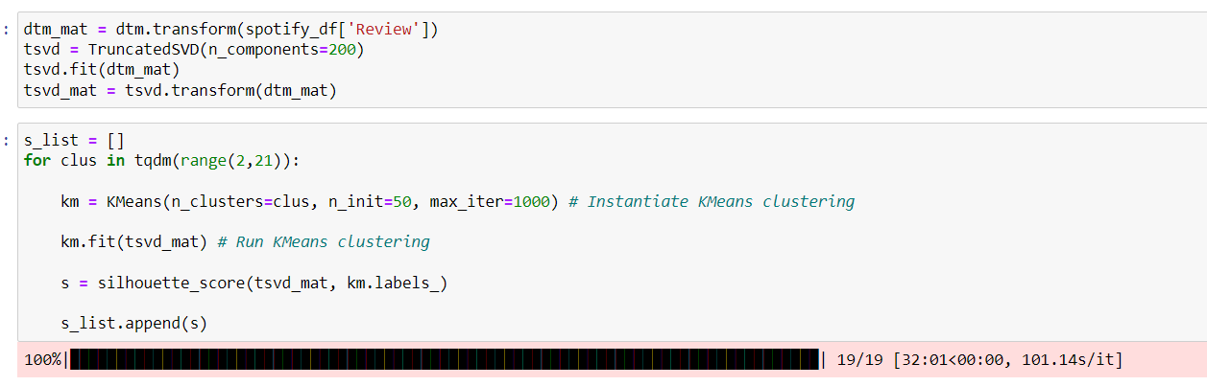
Figure.18 K-Means clustering
In this step we have performed clustering using K means clustering algorithm to group the reviews into the categories. and the silhoutte score has been calculator and it has been plotted in the below figure.
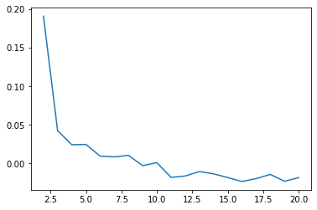
Figure.19 Silhouette score plot
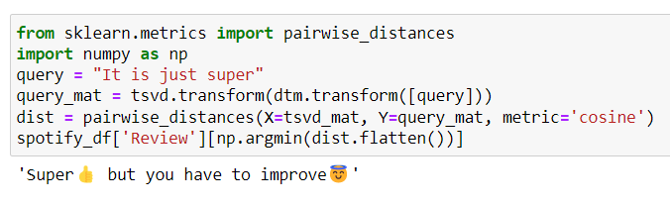
Figure.20 Pairwise Distance
In this step, we have performed a pairwise distances for the new reviews based on the old reviews and the paired review is shown in the above figure.

Conclusion
In this proposed work, we have performed review analysis on the Spotify reviews data set using Latent Dirichlet Allocation (LDA) and Latent Semantic Analysis (LSA) algorithms. Also, we have performed text analysis using Panda’s library. LDA and LSA are performing very well on text analysis, and it provides unique features of text analysis.
Task - 2

Part 1 FUZZY LOGIC CONTROL BASED SMART HOME APPLICATION
The field of application of fuzzy set theory, fuzzy reasoning, and fuzzy logic that sees the most active research activity is known as fuzzy logic control, or FLC for short. FLC may be used for a wide variety of applications, including the control of industrial processes, biomedical instruments, and even security. When compared to traditional control methods, FLC has shown to be most effective when used to difficult, ill-defined issues that can be managed by an effective human operator despite the lack of prior information of the underlying dynamics of the problem. Fuzzy Logic toolbox in the MATLAB is the most important place to create enormous number of applications for smart home-based application. It will be applicable for all kind of fields. By utilizing the FIS toolbox in MATLAB, we are going to design a smart home-based appliances system to control Fire extinguisher, Air purifier, Water Pump, Fan and Light. To control those appliances, we need to use respective sensor like, fire sensor, pollution sensor, soil humidity sensor and motion sensor.

Fuzzy logic control system
There are a variety of control applications where fuzzy logic has been used quite well. Most consumer goods have fuzzy control. Regulating the temperature of your home with the use of an air conditioner is one example. Other examples include controlling the anti-braking system used in automobiles, the control on traffic signals, washing machines, big economic systems, and so on.
A control system is an arrangement of physical components that is meant to change one physical system such that it shows specific characteristics that have been predetermined as desirable for that system. Using fuzzy logic in control systems has several benefits, some of which are listed below.
- When using classical control, it is necessary to have a thorough understanding of the underlying model as well as the correct formulation of the objective function. Because of this, using it effectively in many situations is quite challenging.
- We can make use of the human skills and experience when creating a controller thanks to the use of fuzzy logic for control.
- When creating a controller, the most effective use of fuzzy control rules, which are just IF-THEN rules, may be found.

FLC Design Assumptions
Six fundamental assumptions should be considered while constructing fuzzy control systems:
- Input, output, and state variables are visible and controlled.
- Existence of a knowledge body It must be considered that a knowledge body with linguistic rules and input-output data exists.
- There must be a solution.
- Control engineering must find a 'good enough' solution, not an ideal one.
- Fuzzy logic controller must have adequate accuracy.
- Stability and optimality must be open in Fuzzy logic controller design, not expressly addressed.

Architecture of Fuzzy Logic Control
The architecture of the Fuzzy Logic Control system is shown in the following figure (FLC).
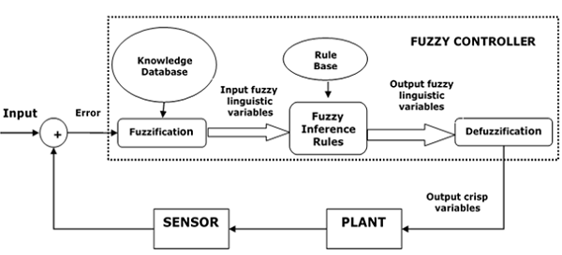
Figure.21 Architecture of the FIS

Principal Constituents of the FLC
The following is a list of the most important parts of the FLC, as illustrated in the picture to the right:
- Fuzzifier: The function of a fuzzifier is to transform the sharp input values into the fuzzy ones that are output.
- Knowledge Base Made of Fuzzy: It is responsible for storing all the information on the input-output fuzzy relationships. In addition to this, it has the membership function, which is responsible for defining the variables that serve as inputs to the fuzzy rule base and those that serve as outputs to the plant that is being controlled.
- The Fuzzy Rule Base is a knowledge repository that contains information about the functioning of the process of the domain.
- The Inference Engine serves in the same capacity as the FLC's kernel. It does this by doing approximation reasoning, which is essentially a simulation of human decision making.
- Defuzzifier: The job of the defuzzifier is to transform the fuzzy values that come from the fuzzy inference engine into clearer, more precise values.

Steps in Designing FLC
The process of designing FLC is broken down into the following steps:
The variables that need to be identified here are the input, output, and status variables of the plant that is now being considered.
- Configuration of Fuzzy Subsets The universe of information is segmented into several fuzzy subsets, and a linguistic name is given to each subset. Always check to see that these fuzzy subsets include all the components that make up the universe.
- Obtaining the membership function Now that we have all the fuzzy subsets that we need from the previous step, we need to acquire the membership function for each one.
- Configuration of the fuzzy rule base at this point, you should start to create the fuzzy rule base by assigning a connection between the fuzzy input and the fuzzy output.
- Fuzzification - The process of fuzzification will begin when this step has been completed.
- Combining fuzzy outputs Using fuzzy approximation reasoning, find the fuzzy output, then combine it with the others.
- Defuzzification In order to get a clear output, you need finally begin the defuzzification process.

Advantages
Now that we have that out of the way, let's talk about the benefits of fuzzy logic control.
- When compared with the development of model-based or other types of controllers, the cost of producing an FLC is much lower than that of these other types.
- FLCs are more resilient than PID controllers because of their ability to handle a far wider variety of operating circumstances than PID controllers can.
- Configurable − FLCs are customizable.
- Imitate human inductive reasoning Essentially, FLC was developed to imitate human inductive reasoning, which is the technique that humans use to draw conclusions based on the information they already possess.
- Reliability The FLC has a higher level of reliability compared to a traditional control system.
- Efficiency When used in control systems, fuzzy logic tends to result in increased levels of efficiency.

Disadvantages
- We will now go on to a discussion of the drawbacks associated with fuzzy logic control.
- Demands a Large Amount of Data The application of FLC requires a large amount of data.
- FLC is beneficial in the case of moderate historical data, but it is not useful for programmes with considerably smaller or bigger historical data than the data it was designed for.
- One of the disadvantages of the system is that it requires a high level of human competence since the accuracy of the system is dependent on the knowledge and experience of human individuals.
- Rules need to be updated on a consistent basis; Rules need to be updated as time goes on.

Implementation of FIS Smart home system
The design and implementation of the FIS based smart home is shown in the below figures in step by step. In our design, we are using trapezoidal membership function for all inputs and outputs.
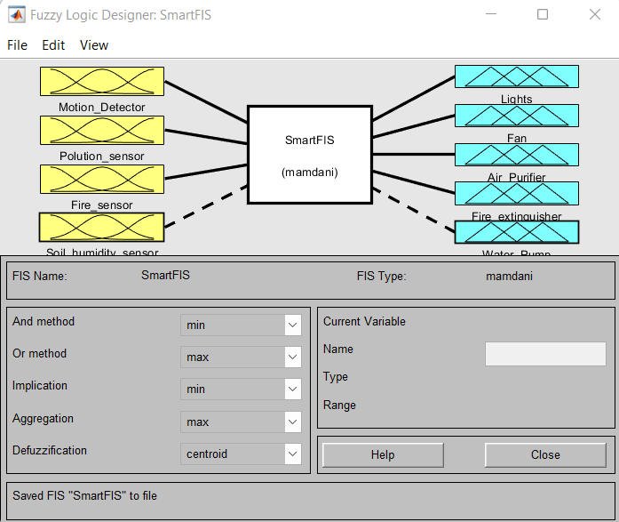
Figure.22 Design of FIS for Smart Home
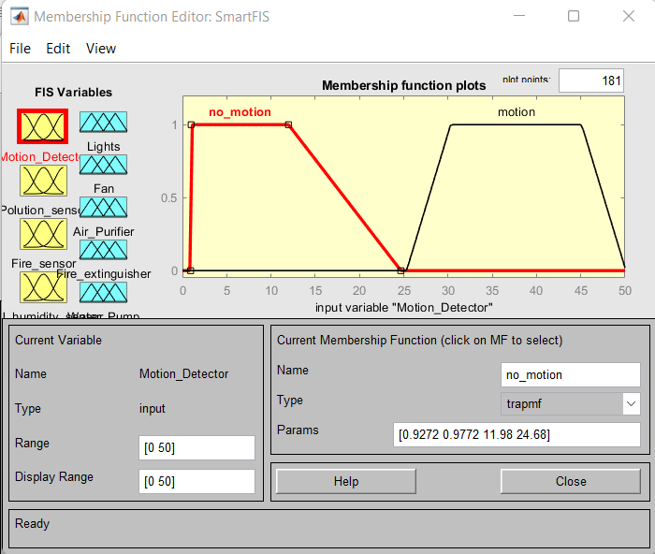
Figure.23 Design of Input and Output Variables
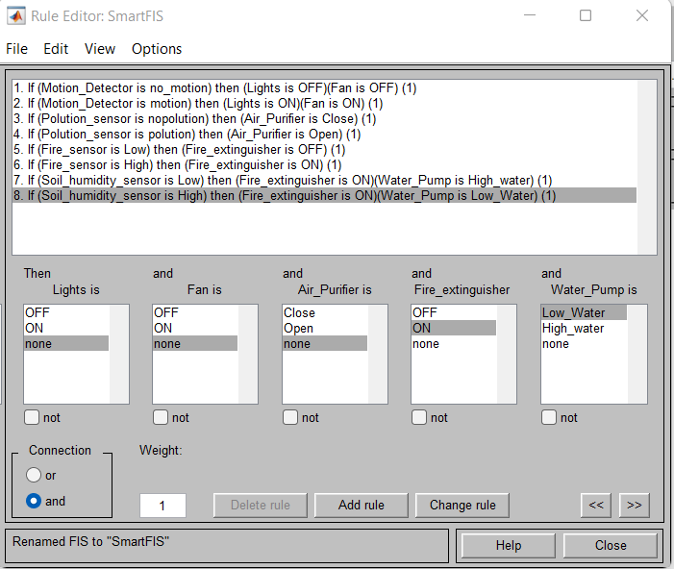
Figure.24 Rule Editor
Rules Design for our smart home system
- If (Motion_Detector is no_motion) then (Lights is OFF) (Fan is OFF) (1)
- If (Motion Detector is motion) then (Lights is ON) (Fan is ON) (1)
- If (Polution_sensor is nopolution) then (Air_ Purifier is Close) (1)
- If (Polution_sensor is polution) then (Air Purifier is Open) (1)
- IF (Fire_sensor is Low) then (Fire_extinguisher is OFF) (1)
- If (Fire_sensor is High) then (Firé_extinguisher is ON) (1)
- If (Soil_humidity_sensor is Low) then (Fire_extinguisher is ON) (Water_Pump is High_water) (1)
- If (Soil_humidity“sensor is High) then (Fire_extinguisher is ON)(Water_Pump is Low Water) (1)
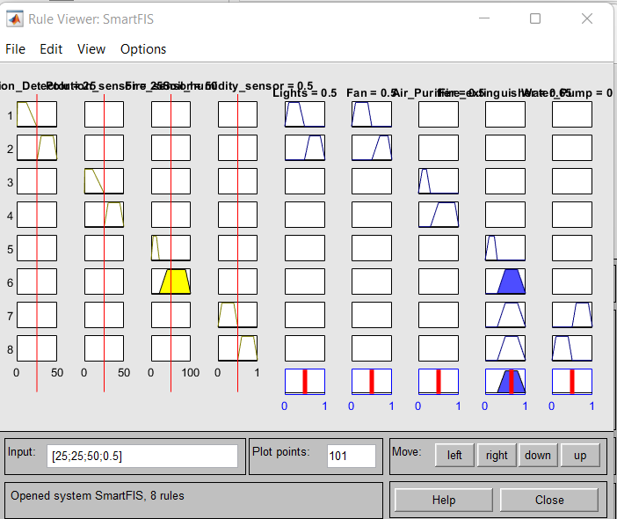
Figure.25 Rule Viewer: Smart FIS
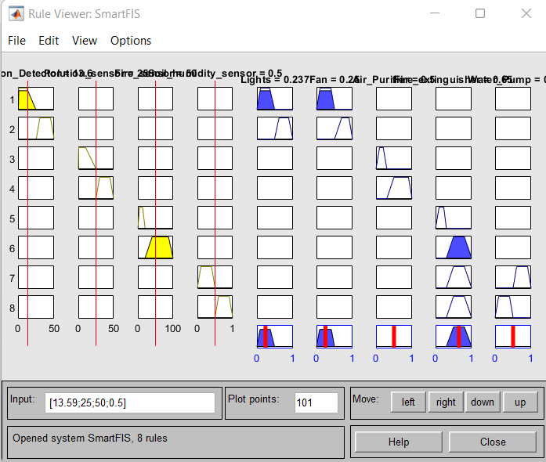
Figure.26 Rule Viewer: Smart FIS
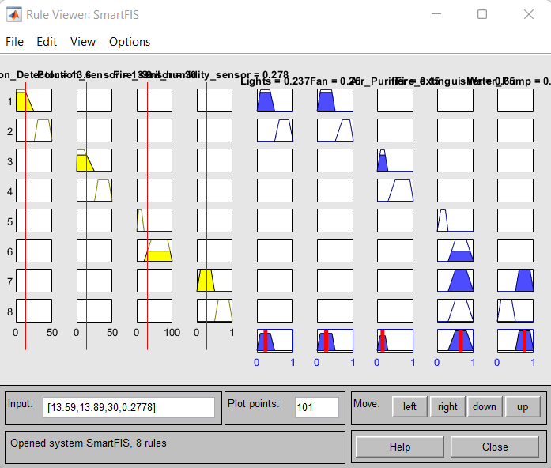
Figure.27 Rule Viewer: Smart FIS all sensor Low
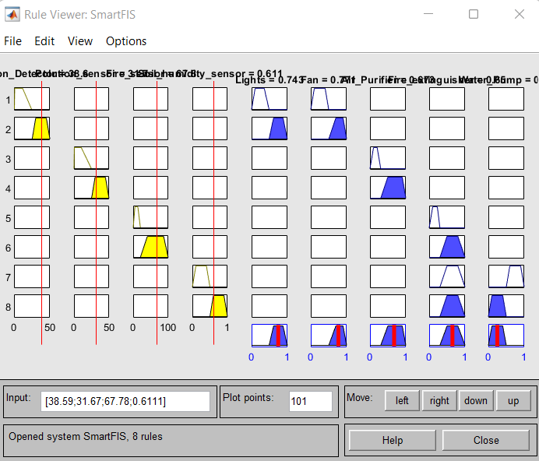
Figure.28 Rule Viewer: Smart FIS all sensor High
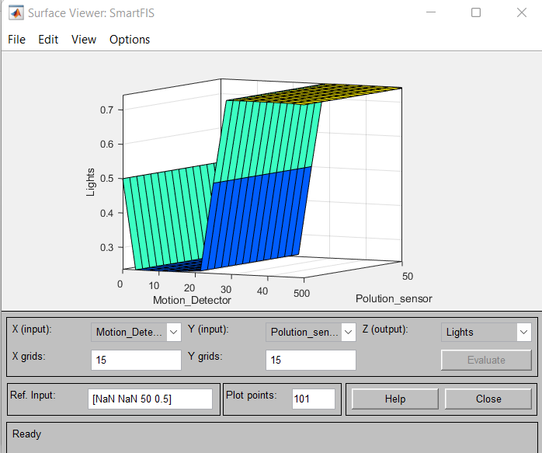
Figure.29 Surface plot for Light and Fan
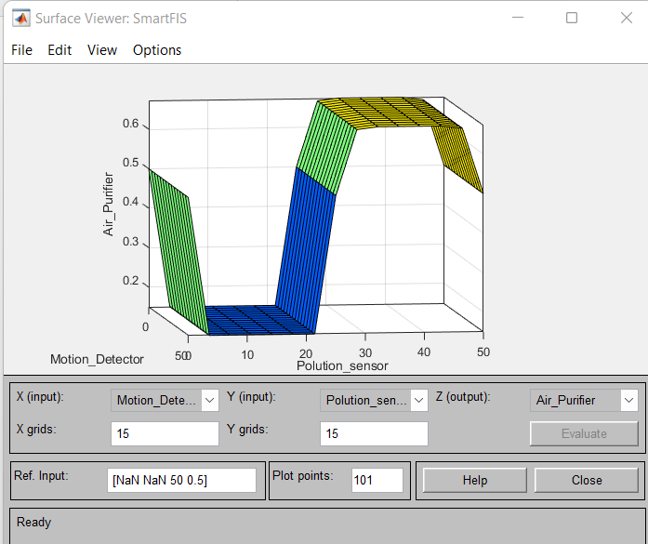
Figure.30 Surface plot for Air Purifier
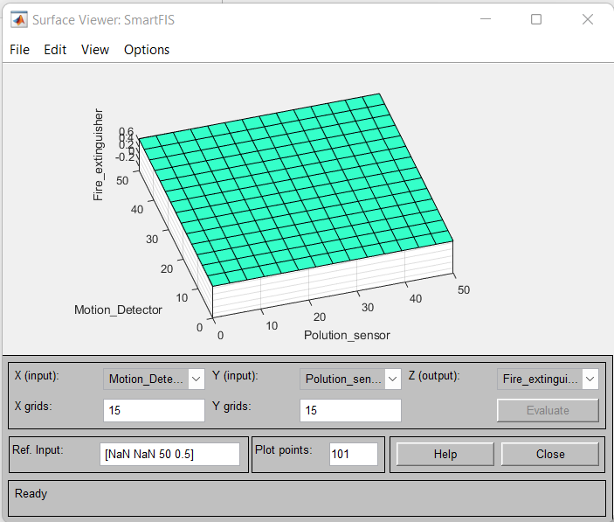
Figure.31 Surface plot for Fire Extinguisher

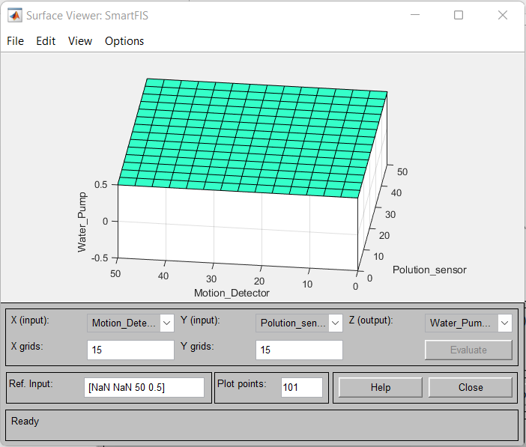
Figure.32 Surface plot for Water pump

Part 2 FIS based smart home application using customised member function
In this part we have created customized membership function for FIS based Smart home application using Genetic algorithm which is used to regulate the input sensor values.
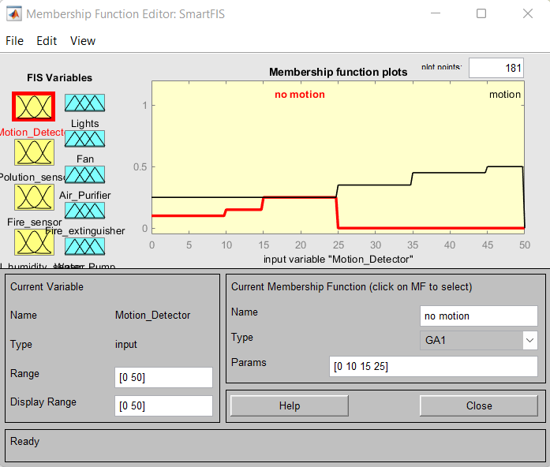
Figure.33 Design of Input and Output Variables
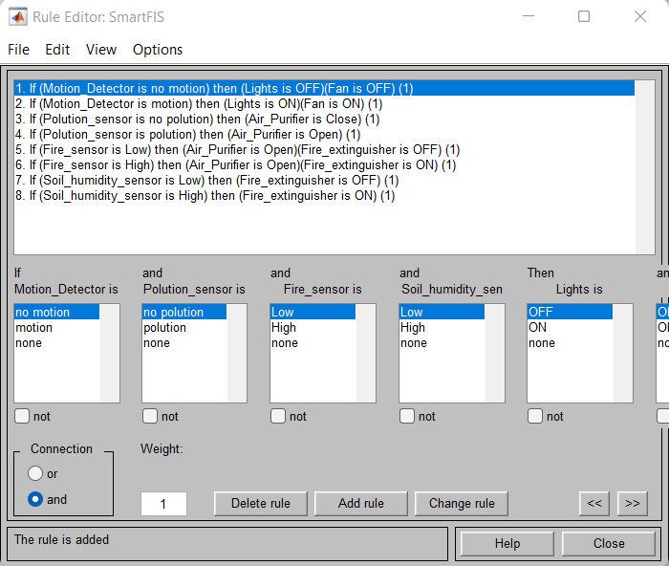
Figure.34 Rule Editor

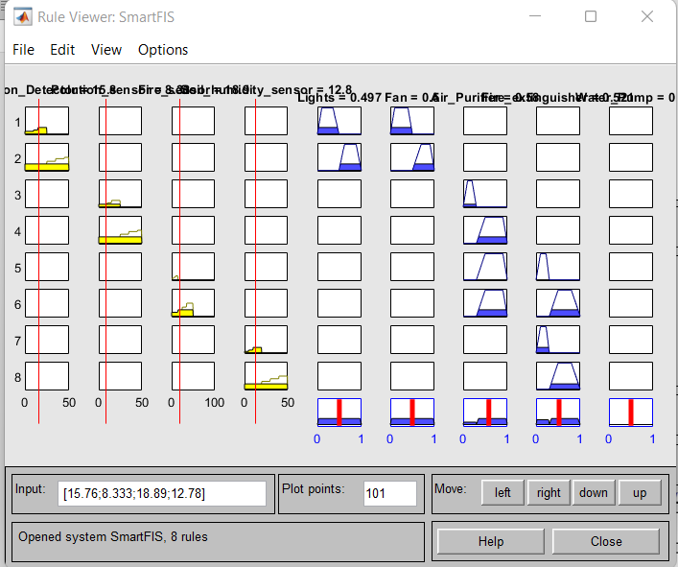
Figure.35 Rule Viewer: Smart FIS all sensor Low

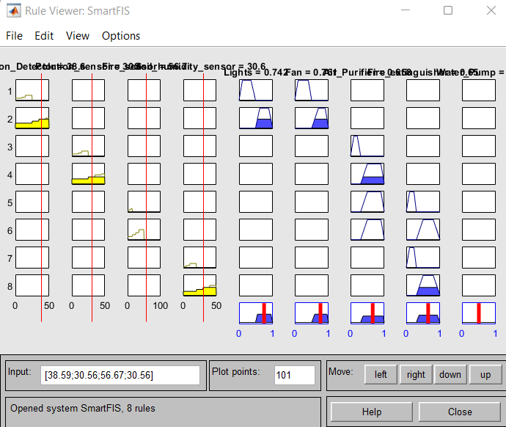
Figure.36 Rule Viewer: Smart FIS all sensor High
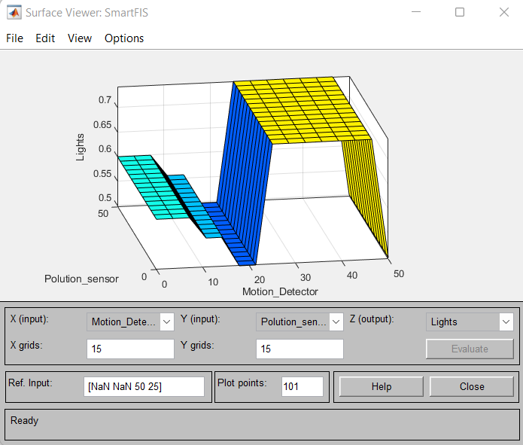
Figure.37 Surface plot for Light and Fan
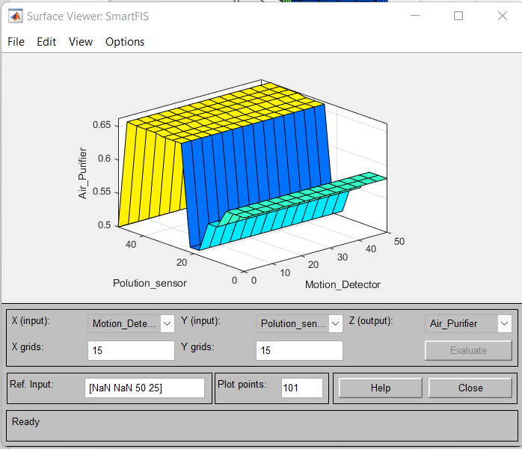
Figure.38 Surface plot for Air Purifier
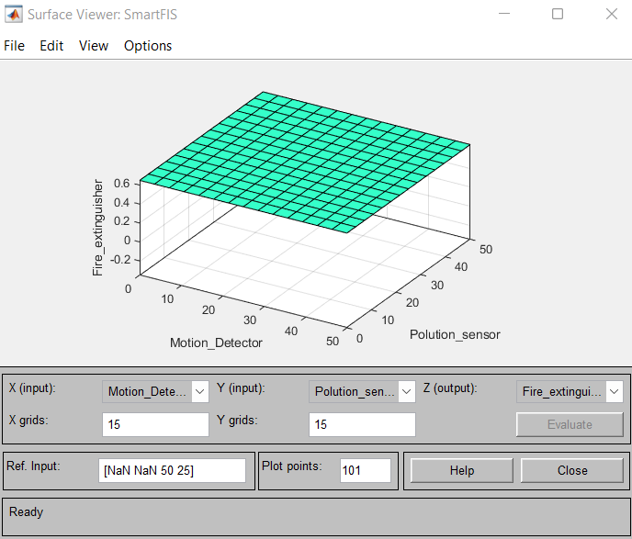
Figure.39 Surface plot for Fire Extinguisher and Water pump
Figure.40 Surface plot for Water pump

Part 3 Optimising CEC 2005 Functions
In this part, we'll look at two different CEC 2005 techniques, with D set at 2 and 10. To optimizing the provided functions, I relied on Ackley and elliptic. I have also identified optimal values for two other kinds of input matrices that have D equal to either 2 or 10. The following is a list of the outcomes that may be achieved by optimization techniques:
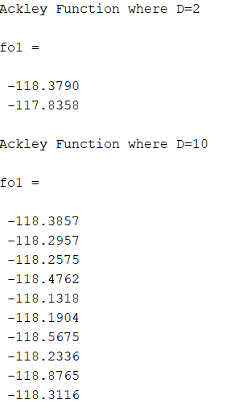
Figure.41 Output for Ackley function
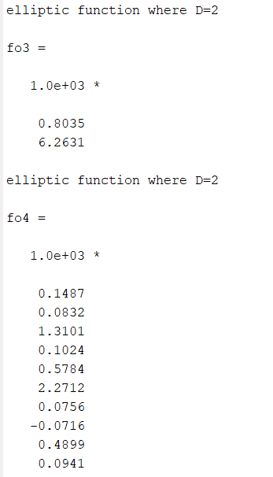
Figure.42 Output for Elliptic function

CONCLUSION
In the part 1 we have designed a FIS based smart home to control light, fan, air purifier, fire extinguisher and water pump based on the input sensor values. In the part 2, we have created customized member function for design created in the part 1. And also, we obtained the comparison surface plot for both designs. And finally in part, we performed comparison on two different functions from the CEC 2005 functions.

REFERENCES
- Barzilay, R. and Elhadad. M., 1997. Using lexical chains for text summarization. In: Proceedings of the Intelligent Scalable Text Summarization Workshop, pp. 10–17.
- Carthy, J., 2004. Lexical chains versus keywords for topic tracking. In: Computational Linguistics and Intelligent Text Processing, LNCS, pp. 507–510. Springer.
- Landauer, T. K. and Dumais, S. T., 1997. A solution to Plato's problem: The Latent Semantic Analysis theory of acquisition, induction, and representation of knowledge. Psychological Review, 104(2), 211-240.
- Novischi, A. and Moldovan, D., 2006. Question answering with lexical chains propagating verb arguments. In: Proceedings of the 21st International Conference on CL and 44th Annual Meeting of ACL, pp. 897–904.
- James Barber, “Spotify review: The most popular music service needs to fix some serious issues,” 0-0-2022. [Online]. Available: https://www.techhive.com/article/633283/spotify-review.html.
- Tyler Dye, “Review Analysis: How to analyze customer & product reviews,” https://getthematic.com/insights/review-analysis/, 0-0-2022.
- D. M. Blei, "Probabilistic Topic Models," Comm. of the ACM, vol. 55, p. 77-84, 2012.
- D. M. Blei, A. Y. Ng, and M. I. Jordan, "Latent Dirichlet Allocation," J. Mach. Learn. Res., vol. 3, pp. 993-1022, 2003.
- J. McAuliffe and D. Blei, "Supervised topic models," Adv. in Neur. Inf. Proc. Sys., p. 121- 128, 2008.
- J. Jagarlamudi, H. Daume, and R. Udupa, "Incorporating Lexical Priors into Topic Models," presented at the EACL '12, Avignon, France, 2012.
- D. M. Blei, T. L. Griffiths, and M. I. Jordan, "The Nested Chinese Restaurant Process and Bayesian Nonparametric Inference of Topic Hierarchies," J. ACM, vol. 57, 2010.
- D. Newman, A. Asuncion, P. Smyth, and M. Welling, "Distributed Algorithms for Topic Models," J. Mach. Learn. Res., vol. 10, pp. 1801-1828, 2009.
- L. El Ghaoui, V. Pham, G.-C. Li, V.-A. Duong, A. Srivastava, and K. Bhaduri, "Understanding Large Text Corpora via Sparse Machine Learning," Stat. Anal. & Data Mining, vol. 6, pp. 221-242, 2013.
- R. Tibshirani, "Regression shrinkage and selection via the LASSO," J R Stat Soc Ser B, vol. 58, pp. 267–288, 1996.
- H. Zou, T. Hastie, and R. Tibshirani, "Sparse principal component analysis," J Comp. Graph. Stat., vol. 15, pp. 265–286, 2006.
- D. D. Lee and H. S. Seung, "Learning the parts of objects by non-negative matrix factorization," Nature, vol. 401, pp. 788-791, 1999.
- J. Choo, C. Lee, D. K. Reddy, and H. Park, "UTOPIAN: User-Driven Topic Modeling BasedonInteractive Nonnegative Matrix Factorization," IEEE Trans. Vis. and Comp. Graph., vol. 19, pp. 1992-2001, 2013.
- S. Deerwester, S. T. Dumais, G. W. Furnas, and T. K. Landauer, "Indexing by Latent Semantic Analysis," J. of the Amer. Soc. for Inf. Sci. vol. 41, pp. 391–407, 1990.

APPENDIX
Code links:
LSA CODE LINK:
https://colab.research.google.com/drive/1xRRuFFVESF2KDXxfTEF2-vxNYPxCvEU2?usp=sharing

LDA CODE
LINK:
https://colab.research.google.com/drive/1-_ErN9JwjYUvm7cKkEvPTyaxdxw53Ycy?usp=sharing

MATLAB Code
Code link for A,B and C:
A:
https://livecoventryac-my.sharepoint.com/:f:/g/personal/thomasa26_uni_coventry_ac_uk/ElgraDDPUodKs6MmFSnVFMUBFtv7Vzn-eI7_KSCWClPh0A?e=rB9UCu

B:
https://livecoventryac-my.sharepoint.com/:f:/g/personal/thomasa26_uni_coventry_ac_uk/EskYuObRSVlKpBslSdvst6wBg15DY7wKQwZBxZa0luHMWA?e=DuEOOp
C:
https://livecoventryac-my.sharepoint.com/:f:/g/personal/thomasa26_uni_coventry_ac_uk/EisRmhPvAEVIrboeYQfOdFcBCbvBJN-xS40fHEG39T4_Sw?e=bL8kHo

Part B
function outparam = GA1(x_para,para)
i=1;
while i<= length(x_para)
if x_para(i) < para(1)
y_para(i) = para(1);
elseif x_para(i) < para(2)
y_para(i) = para(2);
elseif x_para(i) < para(3)
y_para(i) = para(3);
elseif x_para(i) < para(4)
y_para(i) = para(4)
else
y_para(i) = 0;
end
i=i+1;
end
outparam =y_para'/100;
end
PartC
disp("Ackley Function where D=2")
fn=8;
data1=load('ackley_M_D2.mat');
fo1=benchmark_func(data1.M,fn)
disp("Ackley Function where D=10")
data2=load('ackley_M_D10.mat');
fo1=benchmark_func(data2.M,fn)
disp("elliptic function where D=2")
xdata=load('elliptic_M_D2.mat');
fn=13;
fo3=benchmark_func(xdata.M,fn)
disp("elliptic function where D=2")
xdata=load('elliptic_M_D10.mat');
fo4=benchmark_func(xdata.M,fn)

